**Tasks of Sprint 2:-**

The purpose of this sprint (sprint) is to develop the rest of your user stories. So, you will produce **the full software** that you promised to deliver and planned and wrote the requirements for

**Step 1: Sprint planning**

**1-planning meeting in discuss in each user story**

|  |  |  |  |
| --- | --- | --- | --- |
| History | Work | time for each user story | |
| 16/12/2014 | knowing the rules of the game | 5 hours |
| 17/12/2014 | knowing the rules of the game | 5 hours |
| 18/12/2014 | knowing the rules of the game(help Button) | 5 hours |
| 20/12/2014 | Setting | 5 hours |

**2- Roles of different team members**

|  |  |
| --- | --- |
| **Mohammad Adnan** | Scrum Master |
| **Hazem elshenawy** | Product Owner |
| **محمد محمود ابراهيم** | Developers |
| **عمرو السيد أجمد** | Developers |
| **Anas Sbeinti** | Developers |

**3-table that says who will work on what and when.**

|  |  |  |  |  |
| --- | --- | --- | --- | --- |
| **Work** | **who will do this work?** | **When do this work?** | **What do you in this work?** | **deadline for each product** |
| Design | Mohammad Adnan | 15/12/2014 | Design document that includes these element:   1. Final Class Diagram      1. Sequence Diagrams for the THREE most complex user stories 2. User Interface Design 3. Important Algorithms 4. Important Data Structures 5. Database Design if any | 16/15/2014 |
| Coding | Mohammad Adnan and hazem  Elshenawy | 17/12/2014 | 1. Develop your work according to your plan and work distribution 2. All team members must keep their work in BitBucket repository 3. coding style manual 4. Write suitable comments in your code 5. And Use Javadoc commenting style when applicable. | 22/12/2014 |
| Prepare the User Manual | **Anas Sbeinti** | 18/12/2014 | 1. Installation & User Manual 2. describe how to install and configure each component | 22/12/2014 |
| Presentation | Mohammad Adnan and hazem  Elshenawy | 18/12/2014 | 1. You presentation is about 7~8 minutes and no more than 8 slides and should cover:    1. Your game or system and its features.    2. Your design and the tools you used (Very briefly).    3. A demo of your system.    4. The most important lessons and things your learnt from this project and from the course (honestly; say the truth, even if you feel you did not learn anything) 2. Things you would do differently, if you do the project again | 23/12/2014 |
| Final Report and Software | **عمرو السيد أجمد**  **And محمد محمود ابراهيم** | 18/12/2014 | This is report will include the following:   1. A copy of the planning report, design document and presentation pdf or ppt. (things you submitted earlier) 2. Your burndown chart, minutes of daily meetings and summary of retrospective meeting. 3. Source code and Snapshot (image of the screen) of BitBucket repository. 4. Compiled application, ready to install and run. 5. Installation & User Manual | 2/12/2014 |

Use case Diagram:

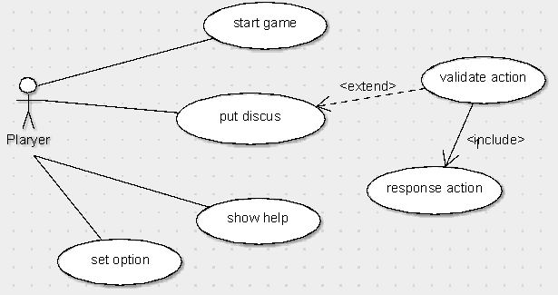

Class Diagram:

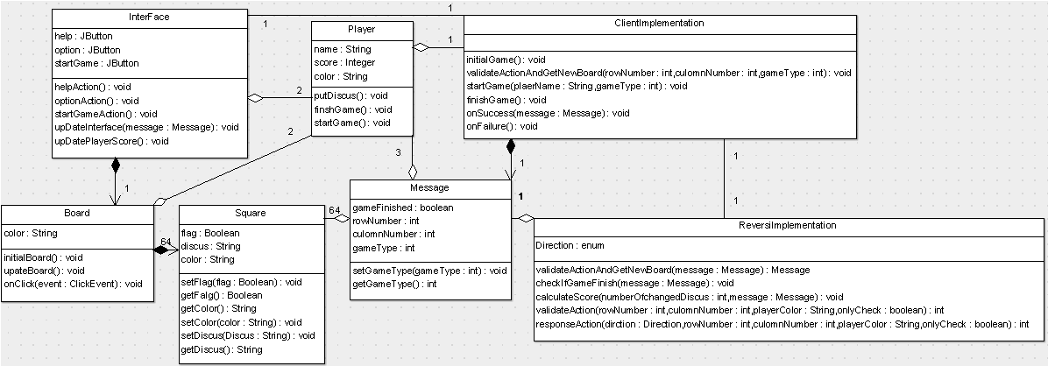

Start Game sequence Diagram:

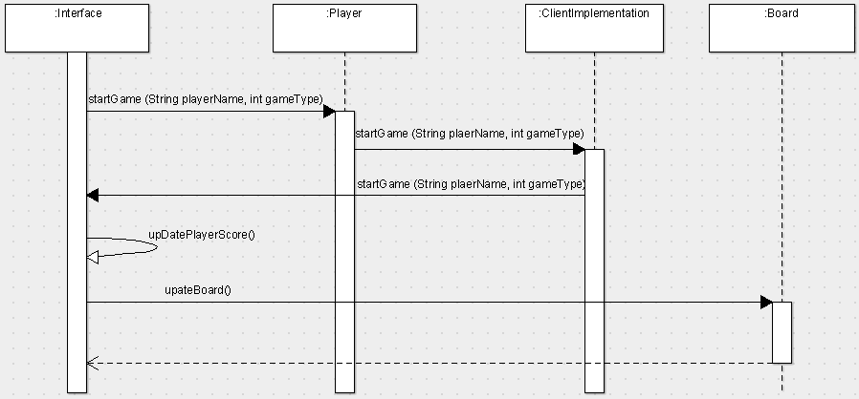

Change Board Color sequence Diagram:

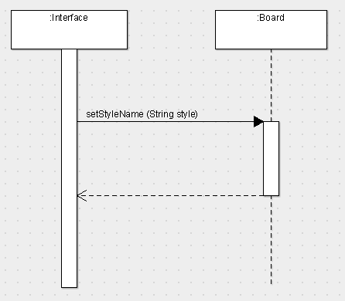

Put Discus Sequence diagram:

